Primary Sources and Transcriptions

Description
This packet includes 5 scanned images of primary source documents and their transcriptions for “Salem, Slavery and the Sacred Cod.” A large image of the primary source on one page is followed by a second page divided in half. The left side of the page shows a smaller image of the document with the citation and credit information below it. The right side of the page is the transcription of the document.

Table of Contents
1762 Letter from Timothy Orne to Captain John Gardner
1764 Account of Sales of the Schooner Pembroke (2 pages)
1792 Invoice of Merchandise Shipped by Elias H. Derby (2 pages)

Description of 1762 Letter
The 1762 letter is an example of a merchant making a request of the ship captain to purchase an enslaved person for their own household. What is also striking is the letter highlights the privilege the entire family has as compared with the enslaved 12-year-old they are about to purchase - in the letter the ship owner/enslaver is allowing his children to make an investment in the voyage, referred to as his “children’s adventure.”

Transcription Guidelines
When transcribing the handwritten document, the overall goals were to (1) make the text more readable and understandable for the audience and (2) to keep as much of the original text as possible. Some documents contain text that is not relevant to the lesson. On these documents, only the yellow highlighted portion on the small image is transcribed.

Donor Recognition and Thank You
This program was made possible by a grant from the National Park Foundation through the generous support of Union Pacific Railroad and donors across the country. Special thank you to The Phillips Library, Peabody Essex Museum, The Hard History Project, and the Lynn, Salem, and Saugus Public Schools.
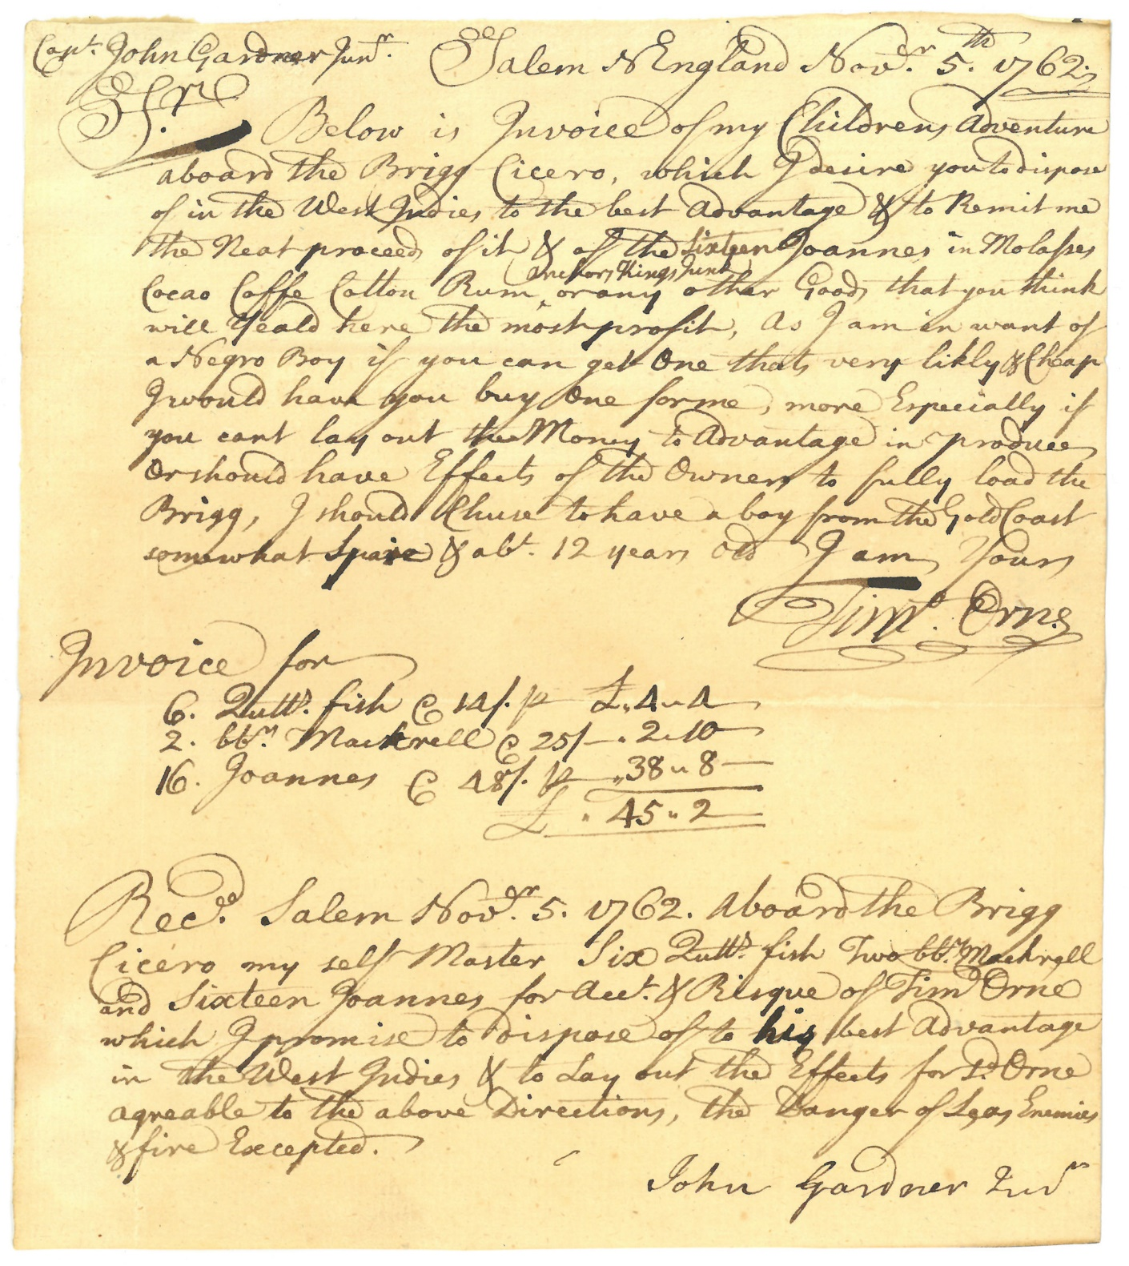

1762 Letter

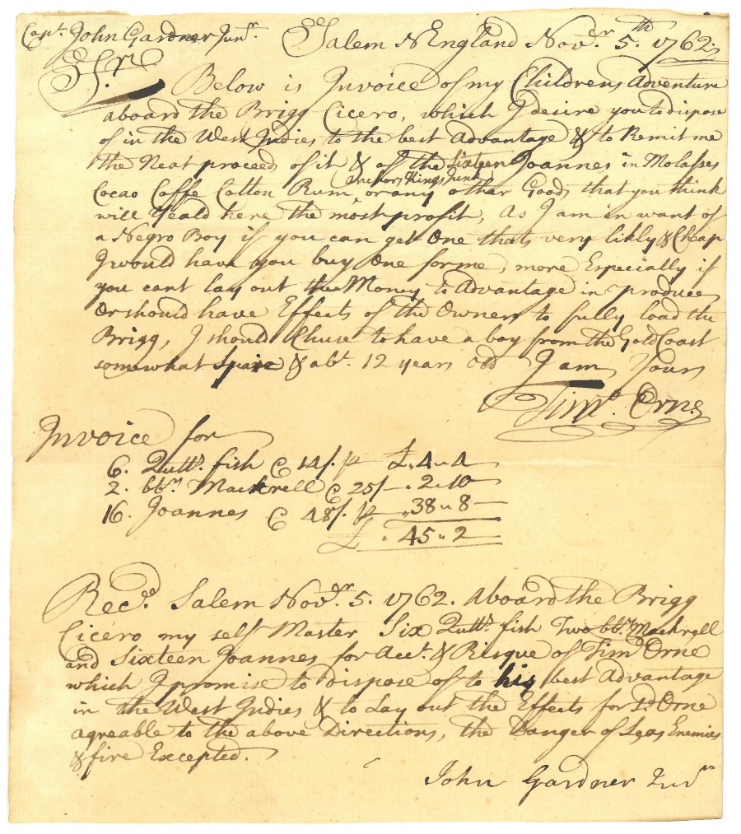

Citation and Credit:
Orne Family Papers, MSS 41, Box 3, Folder 7
Courtesy of The Phillips Library, Peabody Essex Museum, Salem, Mass.

Transcription

Captain John Gardner, Jr. Salem New England Nov. 5, 1762

Sir: Below is an invoice of my children’s adventure aboard the Brigg Cicero, which I assign you to dispose of in the West Indies to the best advantage & to remit me the neat proceed of it and of the 16 Johannes (Portuguese gold coin) in molasses, cocoa, coffee, cotton, rum, or any other goods that you think will yield here the most profit. As I am in want of a Black boy if you can get one that’s very likely & cheap I would have you buy one for me, more especially if you can’t lay out that money to advantage in produce or should have effects of the owner to fully load the Brigg. I should choose to have a boy from the Gold Coast somewhat spry & abt. 12 years old. I am yours, Timothy Orne

Invoice for
6 butts (a type of barrel) fish
2 barrels mackerel
16 Johannes
Received Salem Nov. 5, 1762, Aboard the Brigg Cicero myself Master Six Butts Fish, Two barrels mackerel and 16 Johannes for Account + Risk of Tim Orne which I promise to dispose of to his best advantage in the West Indies + to lay out the effects for Orne agreeable to the above directions, the danger of seas, enemies, and fire excepted. John Gardner, Jr.

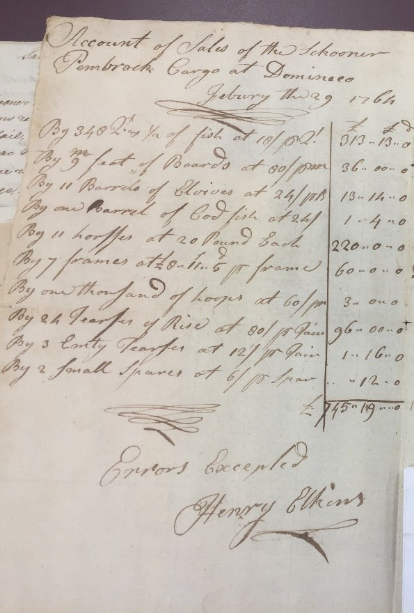

1764 Account of Sales, p. 1

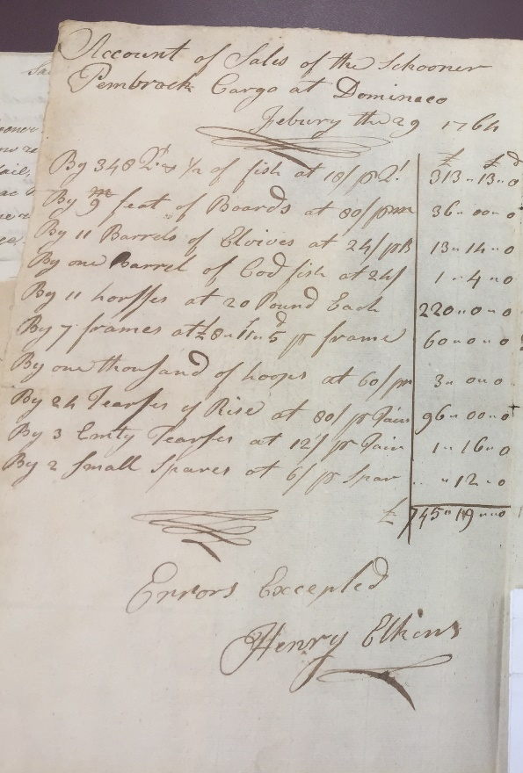

Citation and Credit:
Derby Family Papers, MSS 37, Box 6, Folder 6
Courtesy of The Phillips Library, Peabody Essex Museum, Salem, Mass.

Transcription

Account of Sales of the Schooner Pembroke cargo at Dominica February thru August 1764

By 348 2^{x} & 1/2 of fish at 18/???
By 9 feet of Boards at 80/??
By 11 barrels of Alewives (a type of fish)
By one barrel of cod fish at 24/
By 11 horses at 20 pound Each
By 7 frames at £8.11.5 per frame
By one thousand of hoops at 60/per
By 24 tierces (a type of barrel) of rice at 80/per pair
By 3 empty tierces at 12/per Pair
By 2 small spars at 6/per Spar
Errors Excepted
Henry Elkins

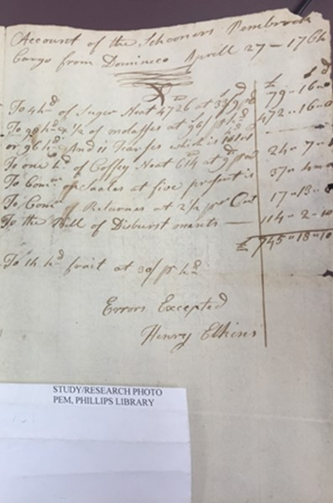

1764 Account of Sales, p. 2

Citation and Credit:
Derby Family Papers, MSS 37, Box 6, Folder 6
The Phillips Library, Peabody Essex Museum, Salem, Mass.

Transcription

Account of the Schooner Pembroke Cargo from Dominica
April 27, 1764

To 4 hogsheads of sugar neat
To 90 hogsheads and a half of molasses
or 96 hogsheads and 11 tierces
To 1 hogshead of coffee neat
To commission on sales at 5 percent
To commission on returns at 2 1/2 percent
To the bill of disbursements

To 1 hogshead ?? at 30/pr hogshead

Errors Excepted
Henry Elkins

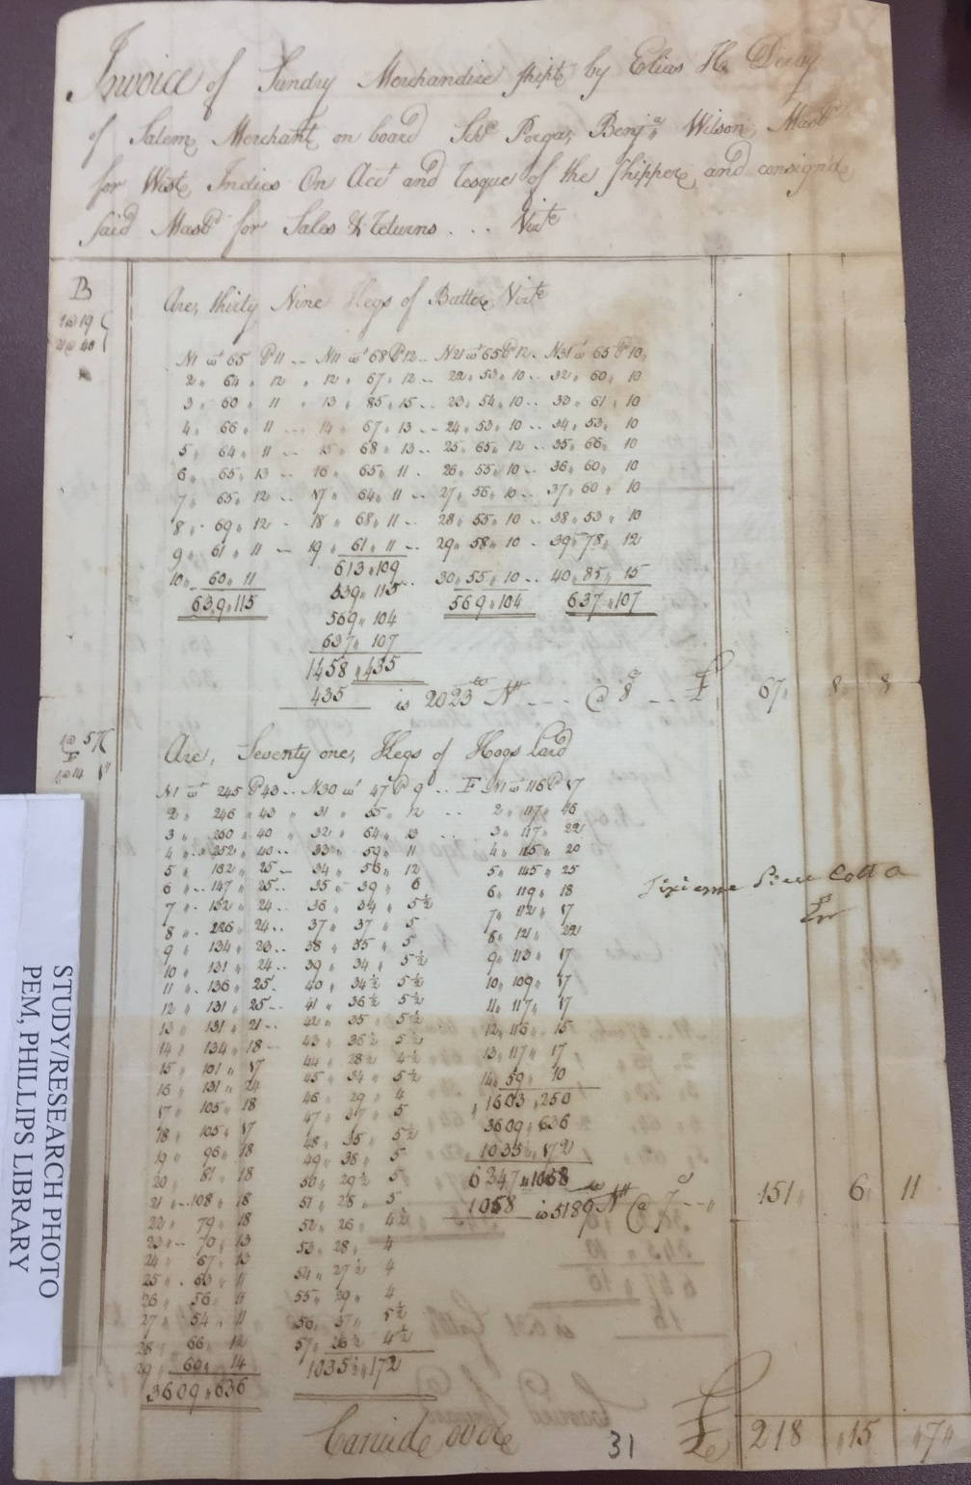

1792 Invoice, p. 1

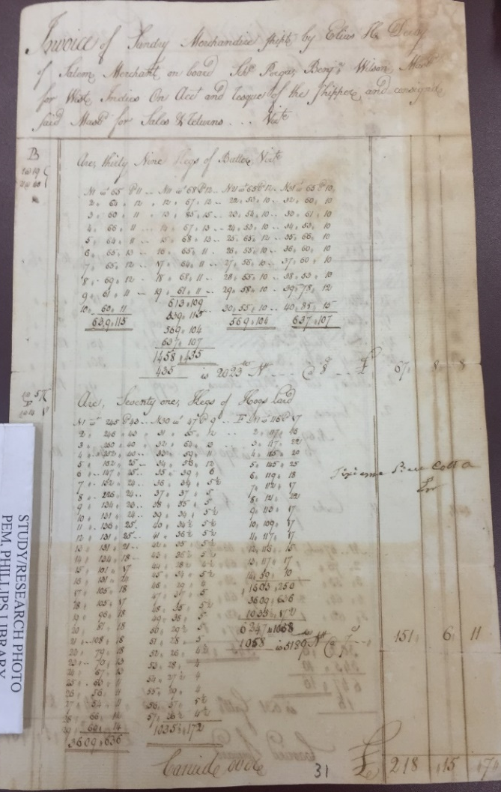

Citation and Credit:
Derby Family Papers, MSS 37, Box 6, Folder 6
Courtesy The Phillips Library, Peabody Essex Museum, Salem, Mass.

Transcription

Invoice of sundry merchandise shipped by Elias H. Derby
of Salem, Merchant on board Schooner Porga, Benjamin Wilson, Master for West Indies on account and risk of the shipper and consigned.

39 kegs of butter, neat

71 kegs of hogs lard

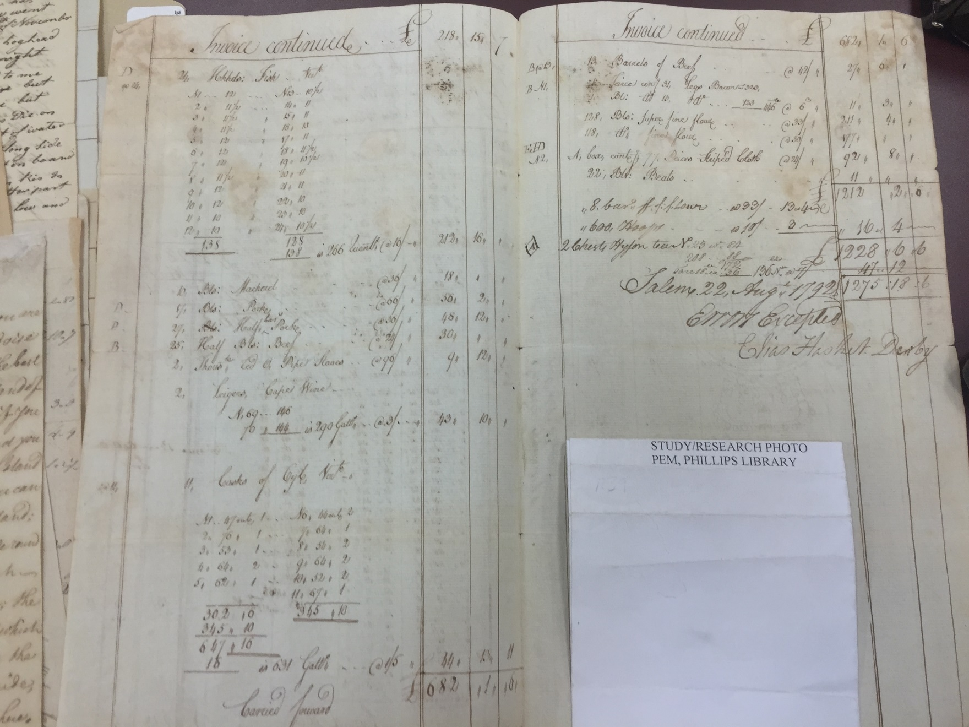
1792 Invoice, p. 2

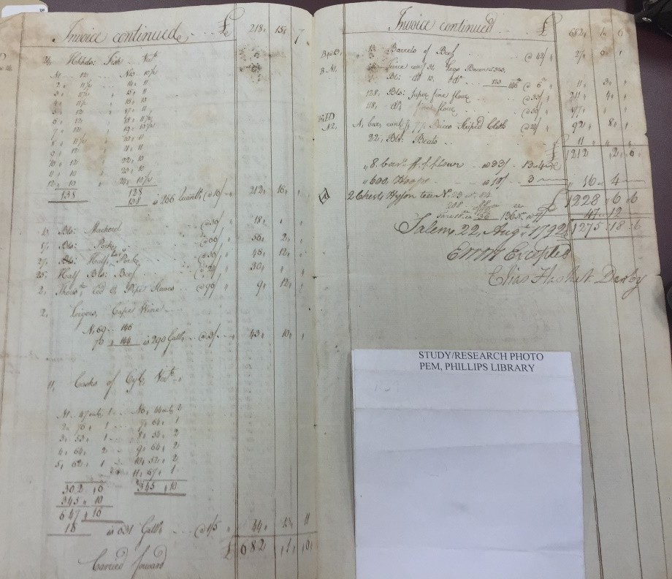

Citation and Credit:
Derby Family Papers, MSS 37, Box 6, Folder 6
Courtesy The Phillips Library, Peabody Essex Museum, Salem, Mass.

Transcription

Hogsheads: Fish
1 barrel of beef
Tierce containing 31 legs bacon
Barrel: ditto
128 barrels super fine flour
118 ditto fine flour
A box containing 77 pieces striped cloth
22 barrels beets
8 barrels superfine flour
600 hoops
2 chests Hyson Tea
Salem 22, August 1792
Errors Excepted
Elias Hasket Derby
10 barrels: Mackerel
7 barrels: Pork
27 Bls: Half Bls: Beef
25 half barrels: Beef
2 thousand [illegible] Pipe Staves
2 ligers Cape Wine

11 casks of oil neat

